LL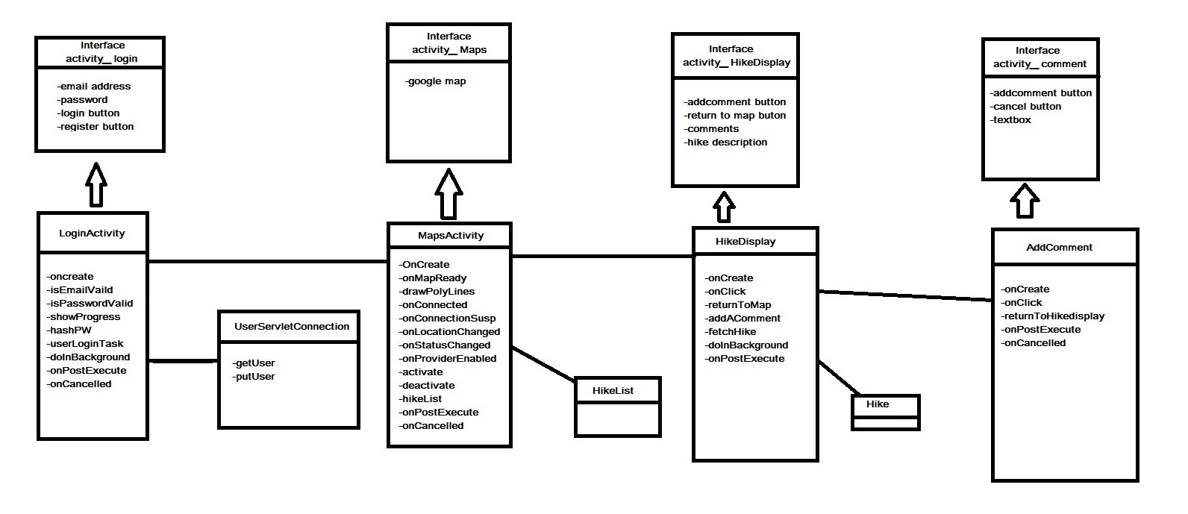

Looking at our class diagram, you can see the application starts at our user log in page. From the user log in page the LoginActivity class connects with the UserServletConnection to check if the user's information is on the server. Once the user is verified by their email and password from the server, the application goes to our MapsActivity page. From the MapsActivity page the app uses the HikeList class to connect to our database and get the hikes from it to display on the map. From the maps page a user clicks on a hike and is brought to our HikeDisplay page. From the HikeDisplay page, the information for the hikes is connected to the app using the Hike class. Once the user can see all of the information about the hikes, they can move to the AddComments class to add a comment about their experience about the hike. Each of the four classes has their own interface that is a .xml file.